Step 1
- Open File Explorer and type CONTROL PANEL in the address bar and hit enter.
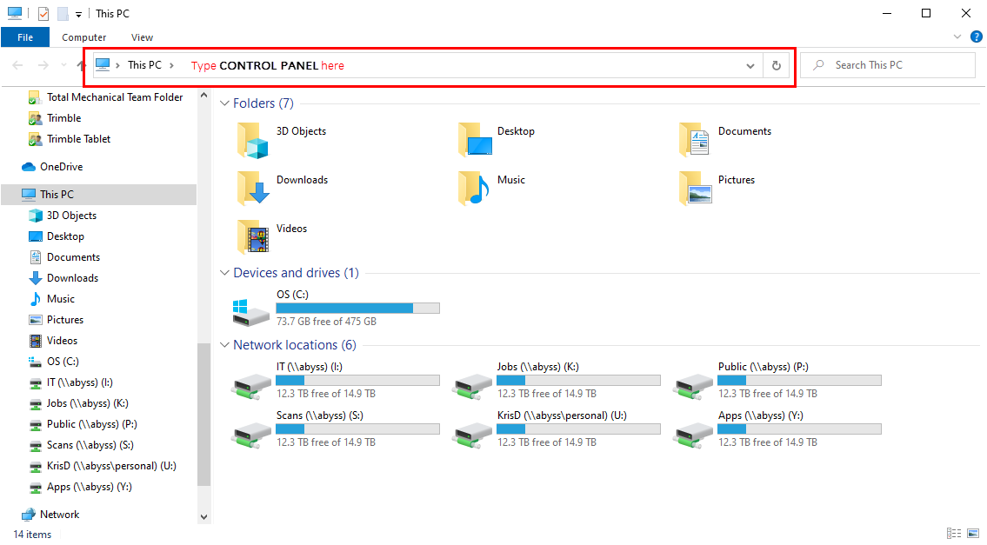

- Under Programs, click Uninstall a program. In the list you are looking for OpenVPN Connect. If OpenVPN Connect is not on your list, proceed to Step 2.
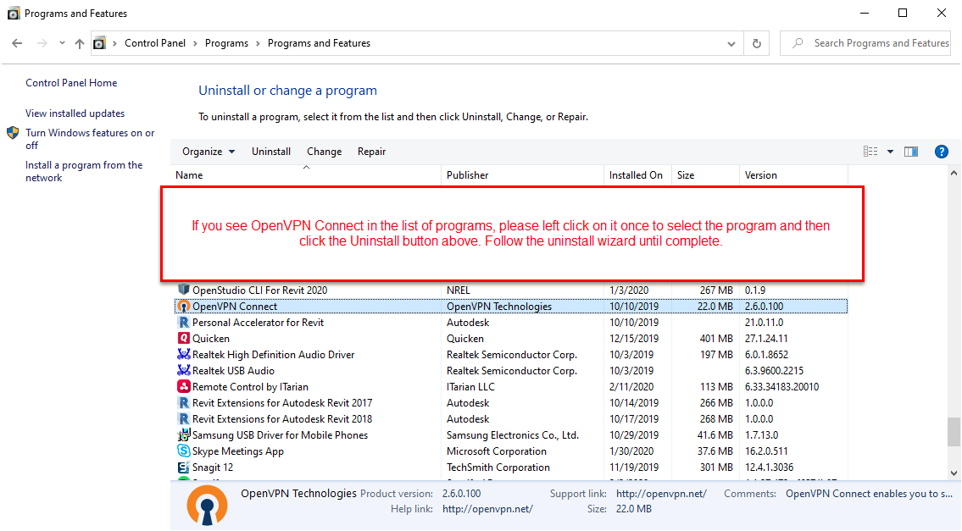
Step 2
- Follow the screenshot guide below. (Note: You may already have a TMI VPN setup. In this case, please proceed to the bottom steps of the next page where you edit your VPN properties.)
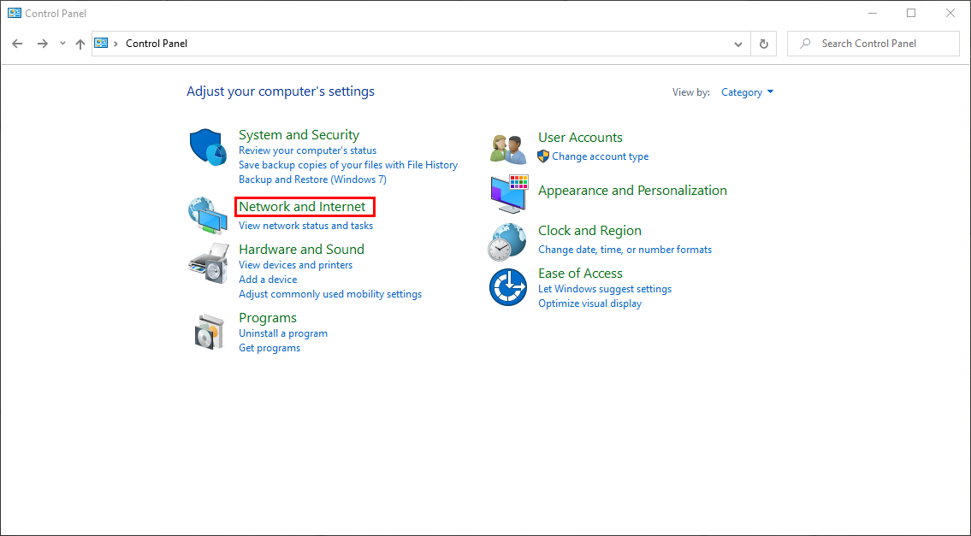
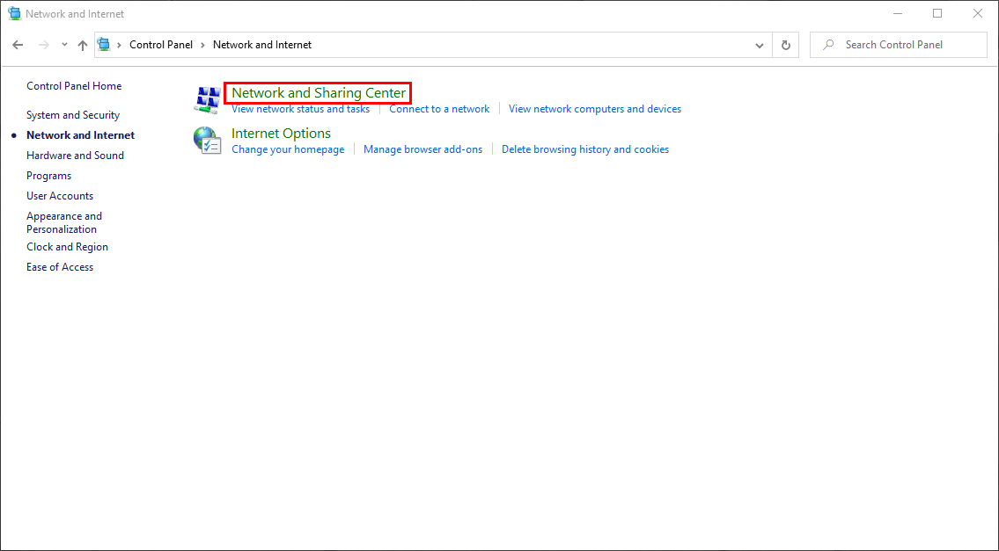

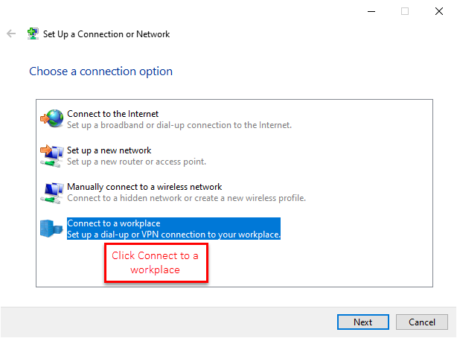
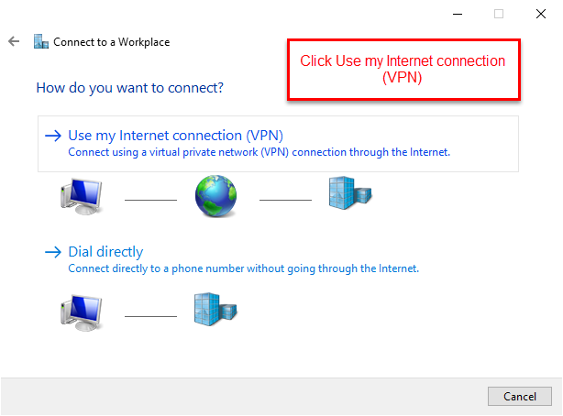

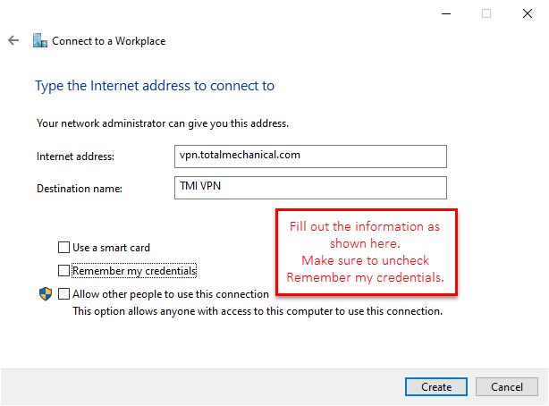
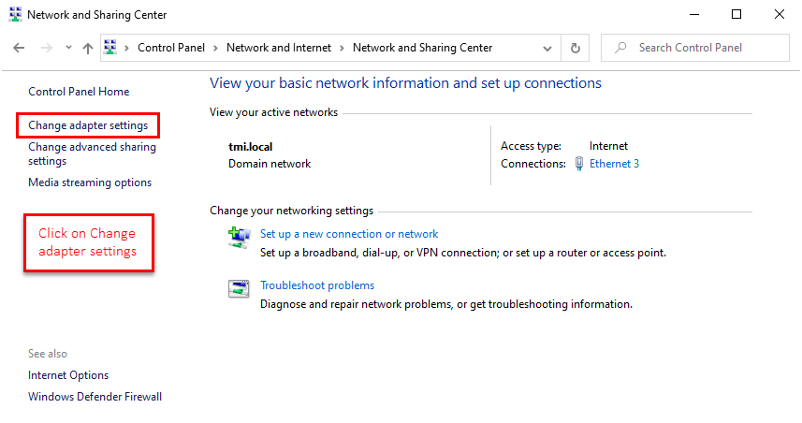
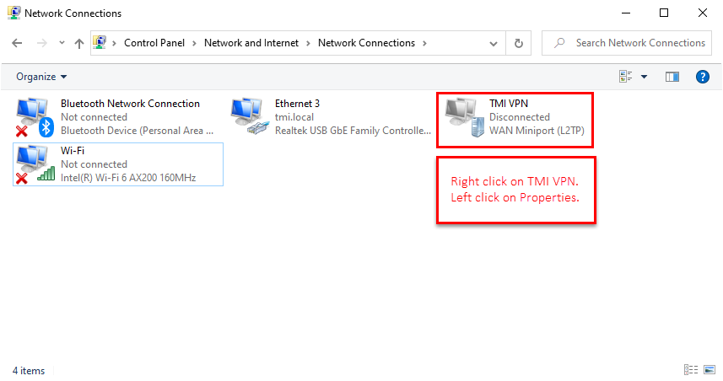
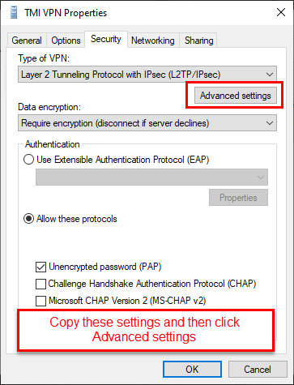
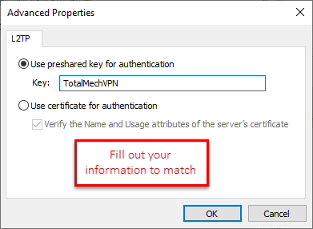
Step 3
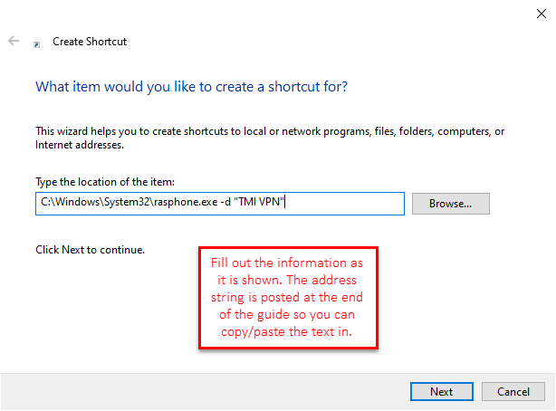
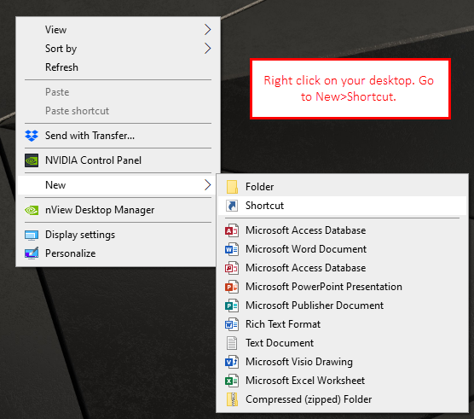
- Now that the VPN has been created you need to create a shortcut to run your connection protocol. Follow the screenshot guide below.

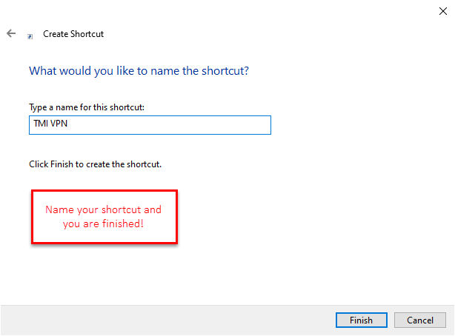

Copy this address string when creating your VPN shortcut.
C:\Windows\System32\rasphone.exe -d "TMI VPN"

